

**Capstone Project Report**

**Report 1 – Project Introduction**

– Hanoi, September 2022 –

**Table of Contents**

I. Record of Changes 3

II. Project Introduction 4

1. Overview 4

1.1 Project Information 4

1.2 Project Team 4

2. Product Background 4

3. Existing Systems 4

3.1 System name1 4

3.2 System name2 4

4. Business Opportunity 4

5. Software Product Vision 5

6. Project Scope & Limitations 5

6.1 Major Features 5

6.2 Limitations & Exclusions 6

# I. Record of Changes

|  |  |  |  |
| --- | --- | --- | --- |
| Date | A* M, D | In charge | Change Description |
|  |  |  |  |
|  |  |  |  |
|  |  |  |  |
|  |  |  |  |
|  |  |  |  |
|  |  |  |  |
|  |  |  |  |
|  |  |  |  |
|  |  |  |  |
|  |  |  |  |
|  |  |  |  |
|  |  |  |  |
|  |  |  |  |

*A - Added M - Modified D - Deleted

# Definition and Acronyms

|  |  |
| --- | --- |
| **Acronym** | **Definition** |
| PWM | Psychology website |
| AWS | Amazon Web Services |
| BA | Business Analysis |
| BR | Business Rule |
| ERD | Entity Relationship Diagram |
| GUI | Graphical User Interface |
| PM | Project Manager |
| SDD | Software Design Description |
| SPMP | Software Project Management Plan |
| SRS | Software Requirement Specification |
| UAT | User Acceptance Test |
| UC | Use Case |
| API | Application Program Interface |
| SCA | Skin condition assessment |

# II. Project Introduction

## 1. Overview

### 1.1 Project Information

* Project name: Spa Service Providing System
* Project code: SSP
* Group name: SWP490_G51
* Software type: Web application

### 1.2 Project Team

|  |  |  |  |
| --- | --- | --- | --- |
| **Full Name** | **Role** | **Email** | **Mobile** |
| Le Thanh Hai | Lecturer | Hailt10@fe.edu.vn | 0912656836 |
| Hoang Manh Ha | Leader | HaHMHE140295@fpt.edu.vn |  |
| Nguyen Nhu Chuong | Member | ChuongNNHE140285@fpt.edu.vn |  |
| Pham Kieu Trinh | Member | TrinhPKHE140643@fpt.edu.vn |  |
| Tran Nam Long | Member | LongTNHE140955@fpt.edu.vn |  |
| Nguyen Trung Dung | Member | DungNTHE140858@fpt.edu.vn |  |

## 2. Product Background

Currently, people have more and more health care need and people's use of spa and beauty care services is increasing. More and more spa service establishments are springing up all over the country. Famous brands such as Beauty Beyond Spa, Thu Cuc Clinic, [herskincare.vn](http://herskincare.vn/), Skin Wisdom, etc. have affirmed their reputation and prestige over the past many years. Although they have built a brand, the above spas still do not have a website that provides good enough services to customers. Their website at first glance is quite full of functions to serve customer needs, but if you go into details, those functions are still only at a basic level. In addition, there are some spas that still use the method of contacting and replying to customers via chat box on Facebook, Instagram. This can take up too much of the customer's time and still not meet their actual needs.

## 3. Existing Systems

### 3.1 herskincare.vn

- Link web: herskincare.vn

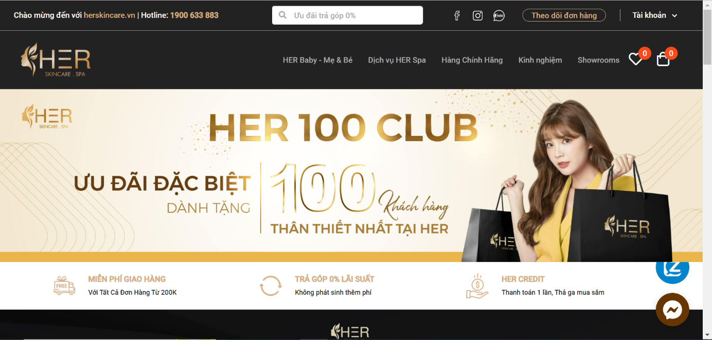

*Figure 3.1.1: herskincare Home Page*

- System functions:

* Store introduction
* Sign in/Sign up
* Sell skincare products
* Sell spa services
* Search product, service by keyword
* Order tracking
* Blog
* Show location of branches
* Chat zalo, messenger
* Link to facebook, instagram, shopee
* Loyal customer
* Favorite product
* Account lookup
* Booking
* Accumulated point lookup

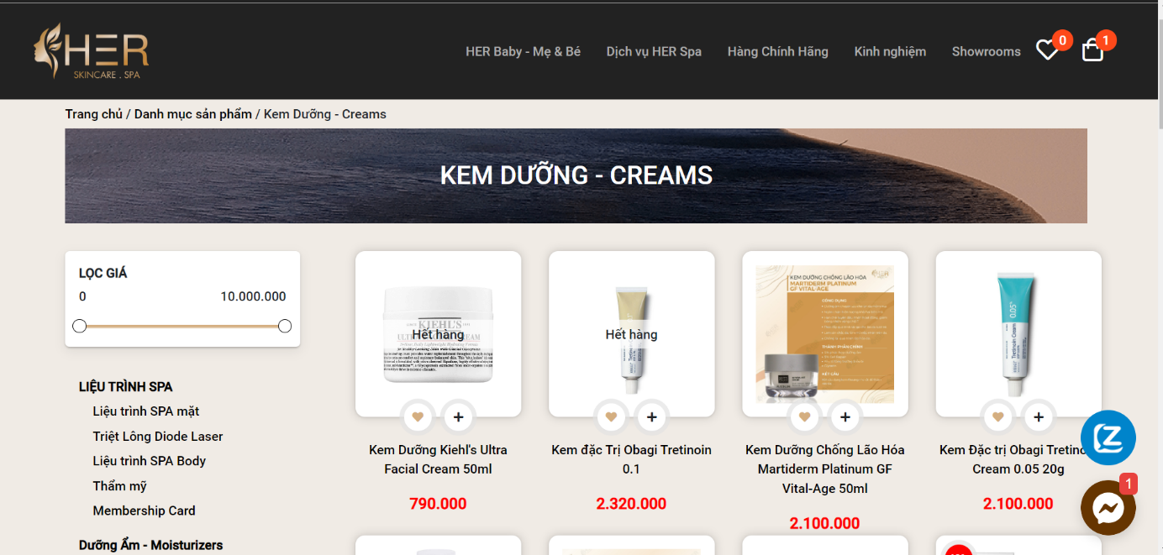

*Figure 3.1.2: Product Selling Page*

Customers can visit the website to view information about the spa services that Her provides as well as the products that Her sells. In addition, customers can also buy spa treatments and products right on the website.

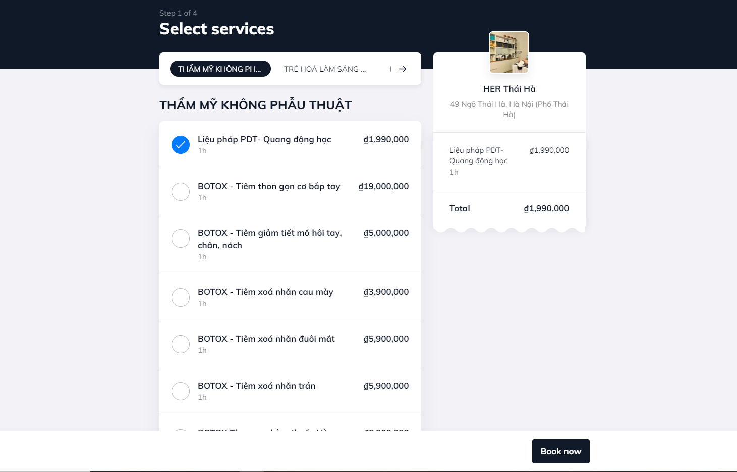

*Figure 3.1.3: Booking Page*

Customers can select services and choose time base on calendar.

|  |  |
| --- | --- |
| **Advantages** | **Disadvantages** |
| * Have full basic functions * Succinct, beauty layout * Wide range of services, products for customer to choose * Fast reload, forward page | * Don’t have realtime chatting on website * Cannot cancel booked appointment schedule * Cannot feedback or report |

### 3.2 Thu Cuc Clinic

- Link web: thucucclinics.com

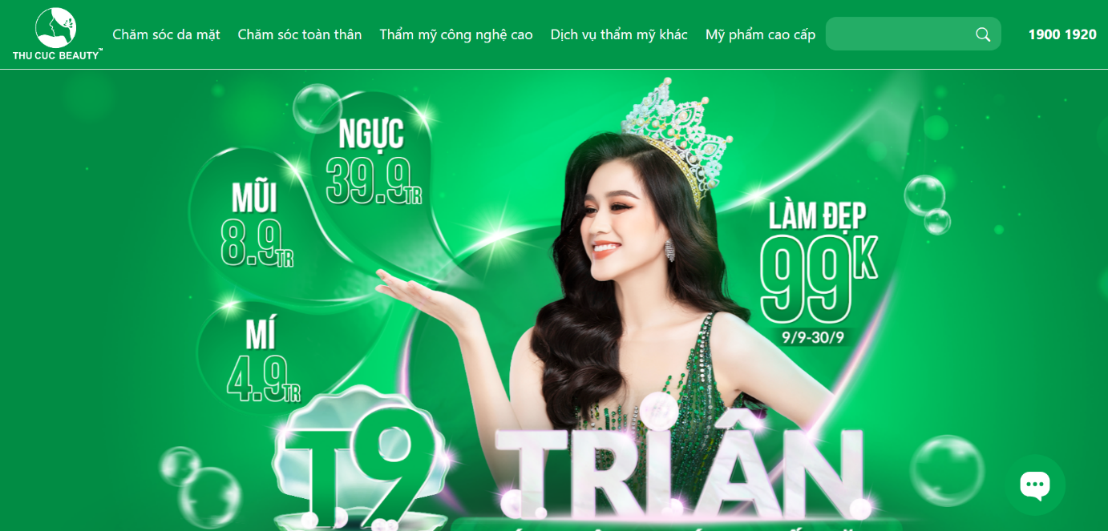

*Figure 3.2.1: Thu Cuc Clinic Home Page*

thucucclinics.com is a website that provides information about services, products and technologies that Beauty Thu Cuc provides.

- System functions:

* Production
* Search post by keyword
* Blog
* Question form
* Leave a message
* Give information about therapeutic services

Customers can access the website to see detailed information of each service such as: Introduction, process, time, cost, …

## 

*Figure 3.2.2: Service detail page*

For consultation, customers need to leave their name, email address, question, phone number and wait for a response from the clinic.

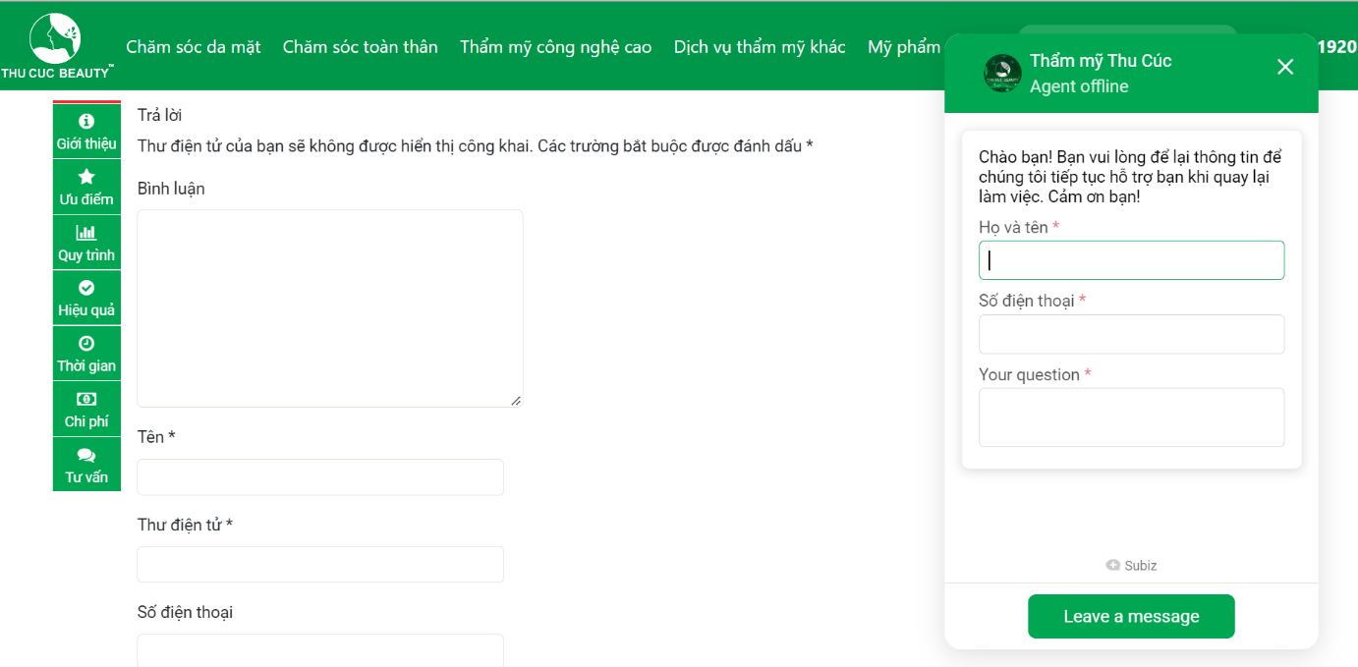

*Figure 3.2.3: Question and message form*

|  |  |
| --- | --- |
| **Advantages** | **Disadvantages** |
| * Provide very detail information about services * Succinct, beauty layout | * Don’t have booking function * Some links cannot connect * Cannot feedback or report |

## 4. Business Opportunity

There are many big spa brands but there are very few of them establish a convenient website for customer. Through the shortcomings in the current market, we want to develop a website providing spa services. We see this as a great potential that we can compete with existing brands on the market based on our superior technology. We guarantee that: On the customer side, it can be easily used, shorten the service selection time, provide real needs. Customers' needs while still ensuring the best efficiency. On the store owner's side, it is easy and quick to grasp the actual needs of customers to manage the store appropriately, helping customers and store owners communicate with each other conveniently.

## 5. Software Product Vision

For healthcare clients looking to book an appointment, the Spa Execution System is an internet-based and smartphone-enabled application that will accept individual and group appointments, process payments and distributing appointments to each spa facility. Unlike the process of booking appointments by phone, Facebook, Instagram... takes time and effort. Customers of Spa Execution System will not have to spend time waiting for answer from the shop owner which will help them be proactive in arranging and saving their own time.

## 6. Project Scope & Limitations

### 6.1 Major Features

*Figure 6.1.1: Major Features of Spa Service Providing System*

|  |  |  |
| --- | --- | --- |
| **ID** | **Major Features** | **Description** |
| FE-01 | Authentication & authorise | User uses account to access the system, different roles access different features of this system. User can register by Google account. |
| FE-02 | Manage booking | This is our main feature. This feature includes different roles:   * Customer role: User can choose services and book an appointment. * Specialist role: User can view detail his working schedule. * Receptionist & Manager role: User can manage all appointments of customer. |
| FE-03 | SCA form | The website has a set of questions about health status for customer. Customer enters their information and problems they are facing. Based on the answers, the website will return a best result for them and recommend services which should be used. |
| FE-04 | Manage system | This feature is designed only for Manager role. Manager will have permission to manage the whole system includes create, update, delete, deactivate account, branch, device, post, service, course, category, data config, voucher, feedback. |

### 6.2 Limitations & Exclusions

**6.2.1 Limitations**

|  |  |
| --- | --- |
| **ID** | **Description** |
| LI-01 | New customers still cannot check the details of health assessment such as body, facial skin, stress, … to be able to advise the best service for customers. |
| LI-02 | Chat realtime don’t activate |
| LI-03 | Some functions need a person to confirm for the system |

**6.2.2 Exclusions**

|  |  |
| --- | --- |
| **ID** | **Description** |
| EX-01 | There is currently no actual payment function |